Project Title: DIGITIZED LECTURE SYSTEM

## List of Group Members:

* 2016-CS-122
* 2016-CS-152

Instructor: Sir. Samyan Wahla

Course: Database Management System

Date of Submission: 5 May, 2019





Table of Contents

Project Title: 1

List of Group Members: 1

Instructor: 1

Course: 1

Date of Submission: 1

Reports 4

Batch wise student report 4

Description 4

Screenshot 4

Course wise student report 4

Description 4

Screenshot 4

Batch wise attendance report 5

Description 5

Screenshot 5

Semester wise attendance report 5

Description 5

Screenshot 5

Course wise employee report 6

Description 6

Screenshot 6

Course wise employee report 6

Description 6

Screenshot 6

Student fee report 7

Description 7

Screenshot 7

Employee salary report 7

Description 7

Screenshot 7

Course wise result report 8

Description 8

Screenshot 8

Batch wise result report 8

Description 8

Screenshot 8

Database Design 9

Description 9

Database Diagram 9

Entity Relationship Model Diagram 10

# Reports

## Batch wise student report

### Description

Detail of each student that belong to the specified batch. Report displays Registration, Semester, First name, Last name and Contact of each student.

### Screenshot

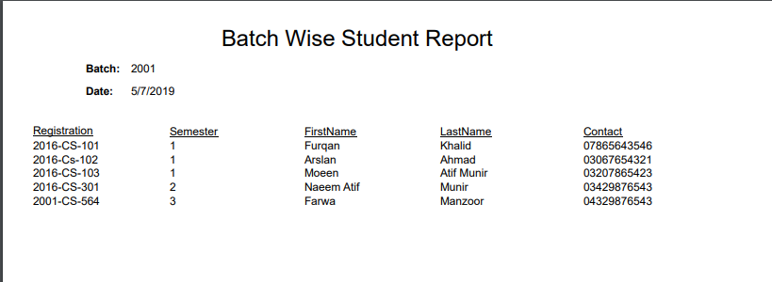

## Course wise student report

### Description

Detail of each student that belong to the specified Course. Report displays Registration, Semester, First name and Contact of each student.

### Screenshot

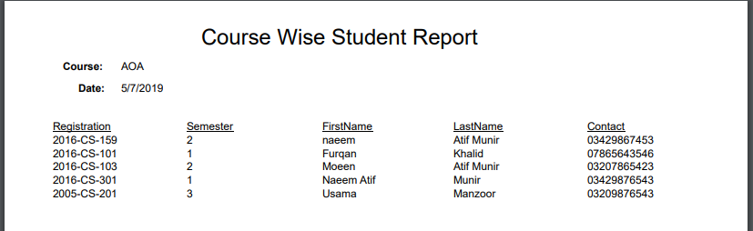

## Batch wise attendance report

### Description

Detail of attendance of each student that belong to the specified batch. Report displays Registration, status, Semester, Course, First name of each student.

### Screenshot

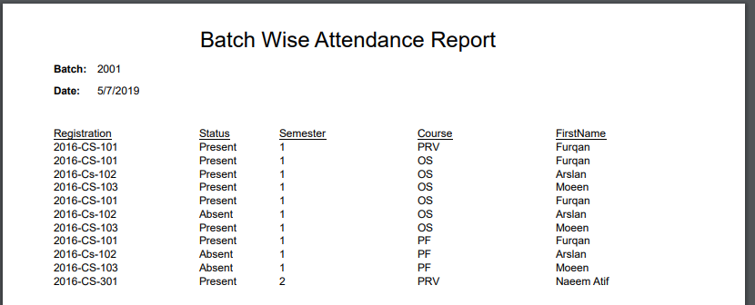

## Semester wise attendance report

### Description

Detail of attendance of each student that belong to the specified semester. Report displays Registration, status, Course, First name and contact of each student.

### Screenshot

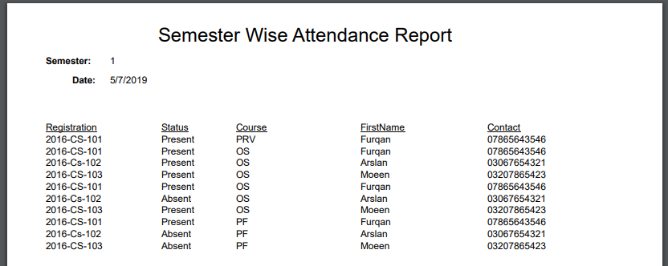

## Course wise employee report

### Description

Detail of each employee that belong to the specified course. Report displays designation, salary, First name, last name and contact of each employee.

### Screenshot

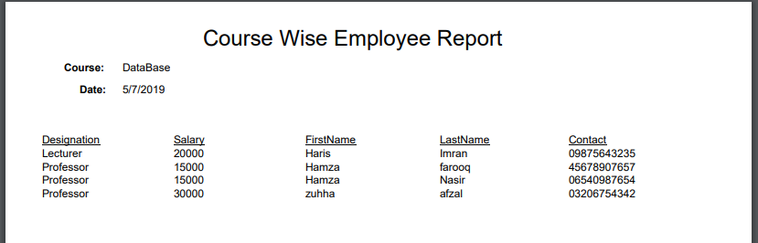

## Course wise employee report

### Description

Detail of each employee that belong to the specified semester. Report displays designation, salary, course, First name, last name and contact of each employee.

### Screenshot

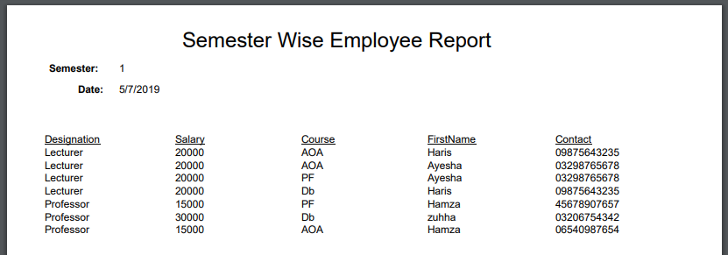

## Student fee report

### Description

Finance detail of each student is displayed in this report. Report’s display fields are student’s registration, monthly fee, total paid fee, current semester, and his/her first name.

### Screenshot

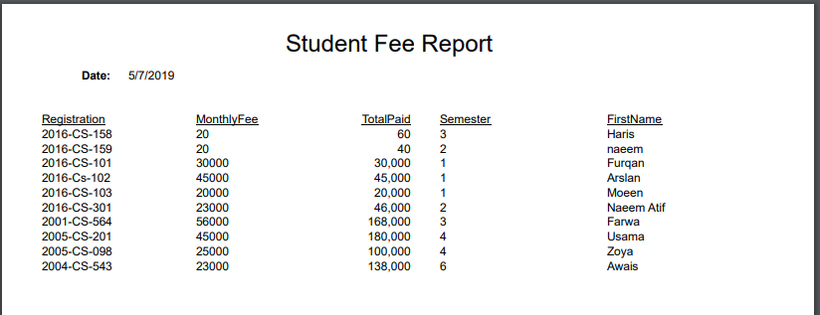

## Employee salary report

### Description

Finance detail of each employee is displayed in this report. Report’s display fields are designation, monthly salary, total paid salary, servicing years, name and contact.

### Screenshot

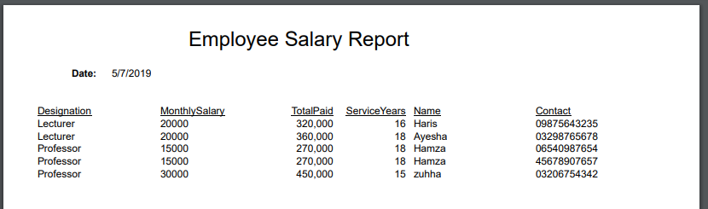

## Course wise result report

### Description

This report displays result detail of each student that belongs to specified course. Report’s display fields are student’s registration, result percentage in each semester, semester, first name, last name.

### Screenshot

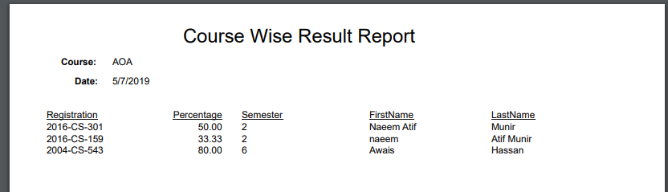

## Batch wise result report

### Description

This report displays result detail of each student that belongs to specified batch. Report’s display fields are student’s registration, result percentage in each course, course, first name, last name.

### Screenshot

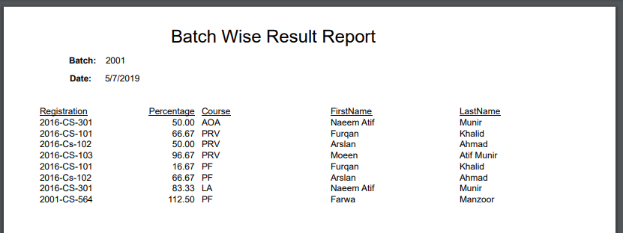

# Database Design

## Description

|  |  |
| --- | --- |
| Property | Description/Value |
| Total Number of Tables | 14 |
| Cross Reference Tables | 3 |
| DBMS Used | MS Sql server |

## Database Diagram

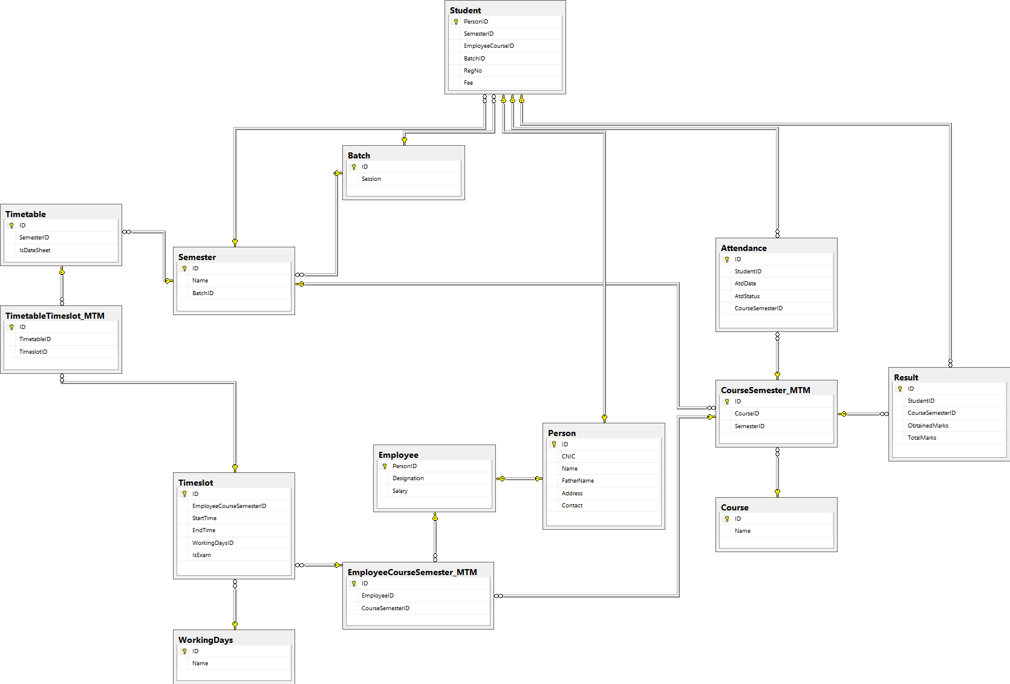

# Entity Relationship Model Diagram

